Dataset Description:

ID,Case Number,Date,Block,IUCR,Primary Type,Description,Location

Description,Arrest,Domestic,Beat,District,Ward,Community Area,FBICode,X Coordinate,Y

Coordinate,Year,Updated On,Latitude,Longitude,Location

**5. Problem Statement**

1. Write a MapReduce/Pig program to calculate the number of cases investigated under each

FBI code



Output screen shot:



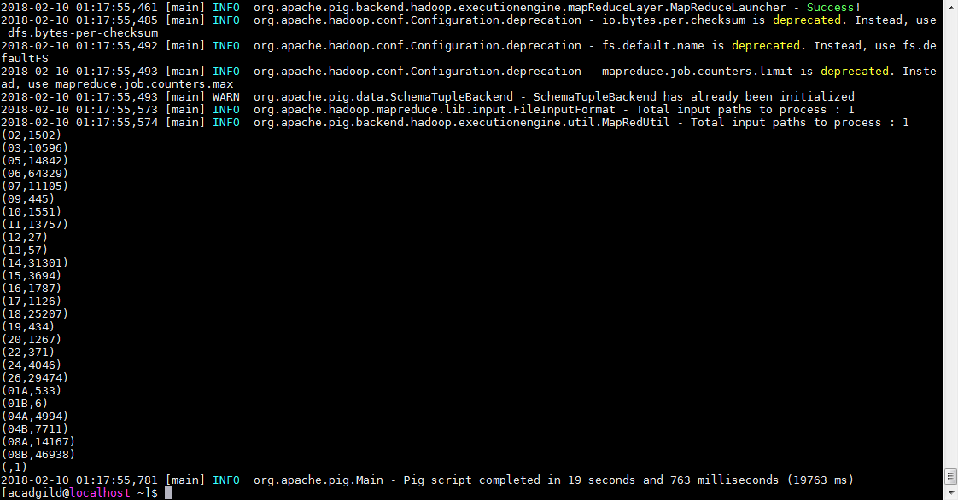

2. Write a MapReduce/Pig program to calculate the number of cases investigated under FBI

code 32





No record present for FBICode =32 hence tried for 2 aswell,please find below second screen shot

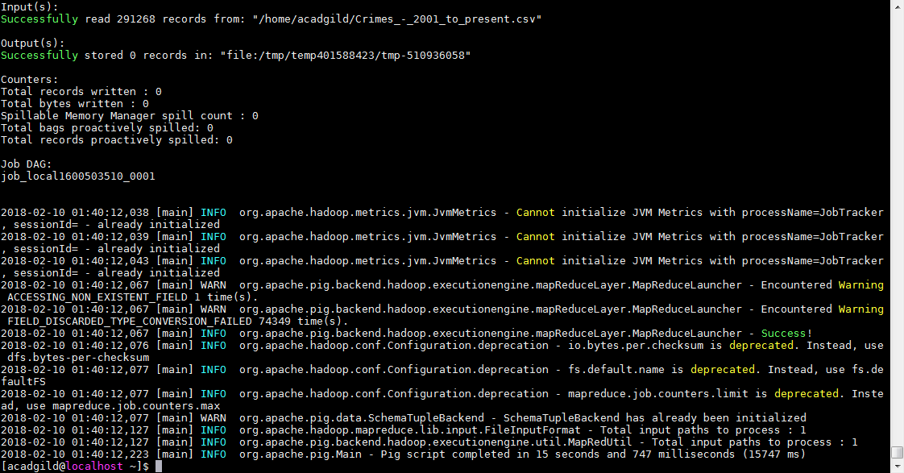

Below result for FBIcode =2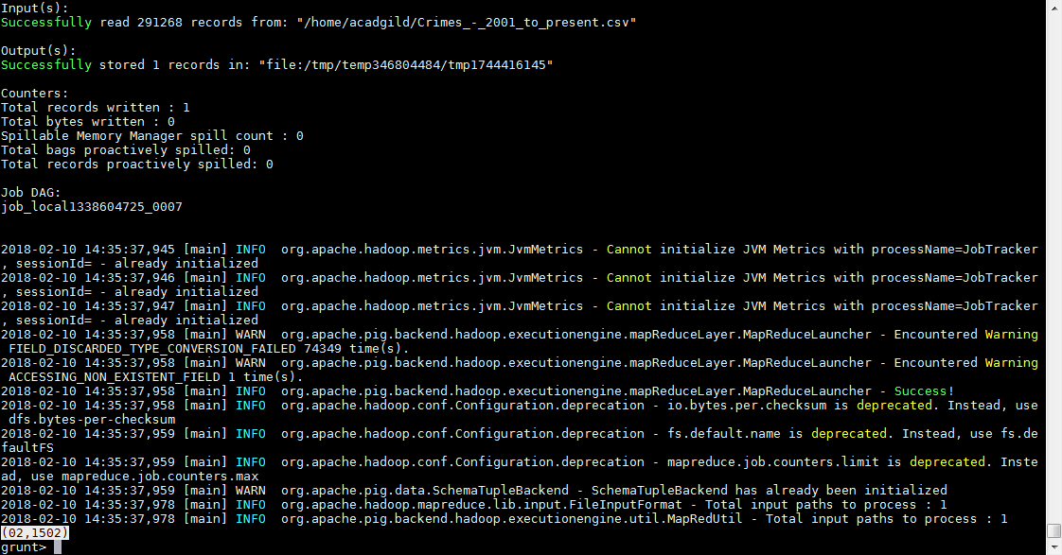

3. Write a MapReduce/Pig program to calculate the number of arrests in theft district wise.





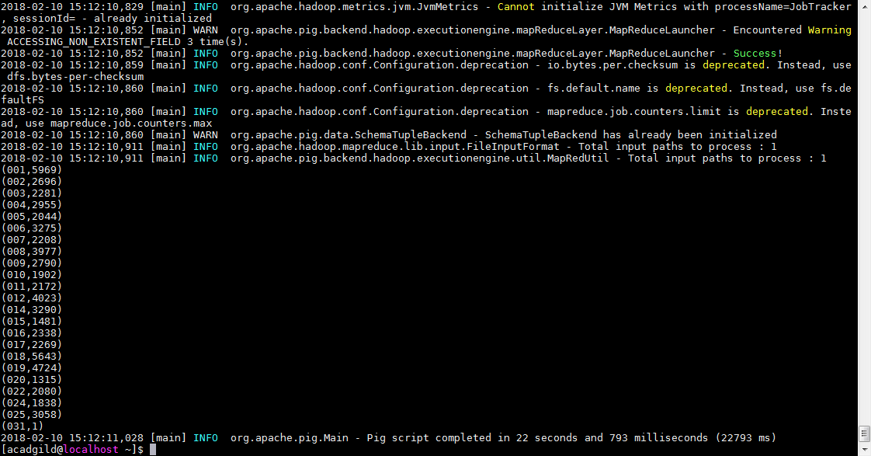

4. Write a MapReduce/Pig program to calculate the number of arrests done between October

2014 and October 2015.





